"Inspiring, very supportive with excellent teachers"
“Enter with an open mind and find it opening in ways you never imagined. Something for everyone in this course”
A weekend retreat in the nurturenature healing garden exploring the relationship between mindfulness and creativity, both of which operate from a basis of more curiosity than fear'!*
Saturday 3rd and Sunday 4th August, nurturenature @ Station House Wortley S35 7DH
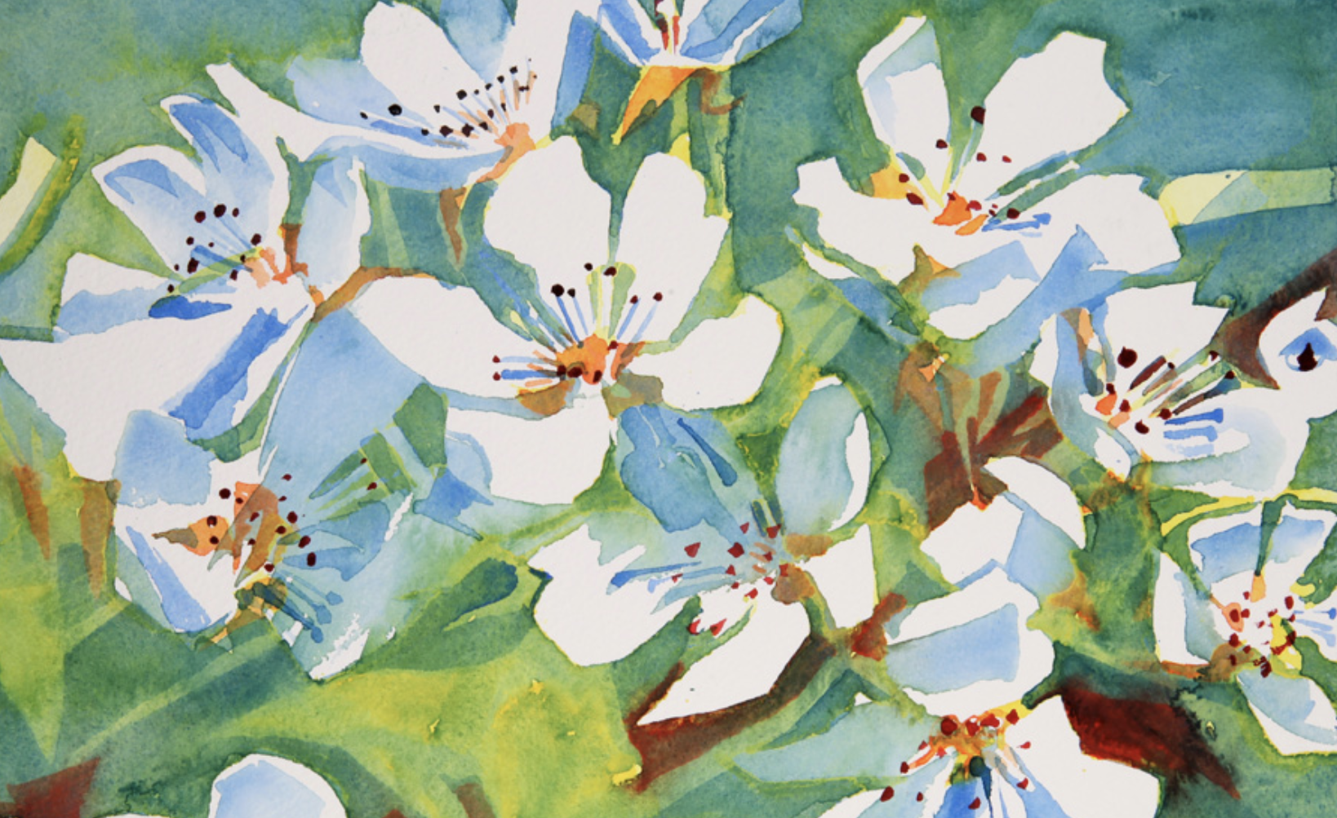

Mindfulness, Drawing and Writing Retreat 3rd & 4th August
(non-residential)
This unique 2-day retreat allows you to explore creativity (drawing and writing) in a fresh way, from a mindful perspective. Each day includes guided meditations, practical creative exercises and group discussions led by two experienced facilitators in a warm, friendly atmosphere with a maximum of 10 participants. The garden venue also allows you to engage with nature and its benefits as part of exploring your creativity.
If you already have a creative pursuit and would like to bring more mindfulness into your practice then this is for you. If the ‘C’ word (creativity) terrifies you this is exactly right for you too!
We invite you to rediscover a childish playfulness to creativity through the means of mindfulness. The physical act of writing or drawing can allow us to be fully immersed in the activity and engage in a subtle relationship with our materials and implements.
This is not simply a drawing or writing class. Nor is it a "quick fix", relaxation class or group therapy session. The goal will not be to have pristine and finished pieces of work to take home, but to use these playful exercises to engage in developing a valuable life skill offering many potential benefits and to leave the weekend feeling refreshed and having enjoyed engaging in new experiences. Feedback from previous course participants has been very positive.

Retreat Schedule
Saturday 3rd and Sunday 4th August, 10.00 – 16.00 each day
Each day consists of a series of mindfulness, drawing and writing exercises encouraging you to bring an attentive openness to each creative activity. It is possible to just attend the Saturday but you will get more benefit if you attend both days.
Refreshments will be provided but please bring your own lunch with you.

Who Can Attend
This course is suitable for beginners (to mindfulness, drawing and writing), as well as those wishing to refresh or deepen their mindfulness practice, or explore their creativity in a new way. We invite everyone to put aside their previous knowledge and experience (or lack of it!) and engage a Beginner’s Mind.

Venue
This event will be held at nurturenature @ Station House, Finkle Street Lane, Wortley, Sheffield S35 7DH in the 1 acre garden which you will be free to explore to stimulate drawing and/or writing. (In the event of bad weather there is an indoor venue in the house.)

Cost

£135 for the two days although there are some subsidised places available.

Tutors
The tutors for this course are Dr. Lauri Bower and Clare Belbin-Carlile, both experienced practitioners.
Lauri has 30 years' experience of meditation practice and 15 years of running and organising retreats. She began teaching Mindfulness Based Stress Reduction (MBSR) courses in 2013, which expanded into Mindfulness and Creativity retreats, workshops and courses in 2015. She completed a Ph.D. in Mindfulness in 2014. To date, over 300 people have completed mindfulness courses with Lauri. She has always engaged with creative pursuits in sewing, dressmaking, embroidery, calligraphy, jewellery and bookbinding and since 2012 has been exploring how the practice of mindfulness informs her poetry writing. She regularly posts poems to her blog and and her creative work to Instagram. She sells handmade books.
Clare is the artist-in-residence at Helmsley Walled Garden and can often be found painting in the garden. She studied Fine Art at Newcastle University and completed her postgraduate in Drawing & Painting at Edinburgh College of Art, exhibiting regularly since then. For twenty-five years, Clare has drawn and painted in two walled gardens. Her work is a daily, animated study through the seasons - winter earth, first shoots, blossom, fruit and leaf fall. This constant change generates a natural curiosity for her to search for ever more fresh observation. Clare has been fully committed to her practice of mindfulness for over twelve years. She sells her prints and cards on her website

FAQs

What aspects of creativity are covered on the course?
Creativity can take many different forms, including how we build a home, cook a meal, or create an atmosphere where people feel relaxed. For the purposes of the course these are specifically writing and drawing as we consider these to be the solid foundations upon which to build creativity into all areas of our lives. All creativity involves an openness to what is in front of us, noticing what is present which is why we use the term ‘more curiosity than fear’.

What further information will I receive?
You will receive a confirmation email once you have booked a place. This will confirm the information on the class dates, venue etc. Please save this email for reference when you arrive on the course.

What is your cancellation policy?
If you cancel your booking at least 7 days before the start of the course we will refund your full course fee minus a £15 administration fee.
If you cancel your booking less than 7 days before the start of the course we will issue a 50% refund of the course fee.
Once the course has started no refunds will be issued.
If the organiser cancels the course you will be refunded in full.
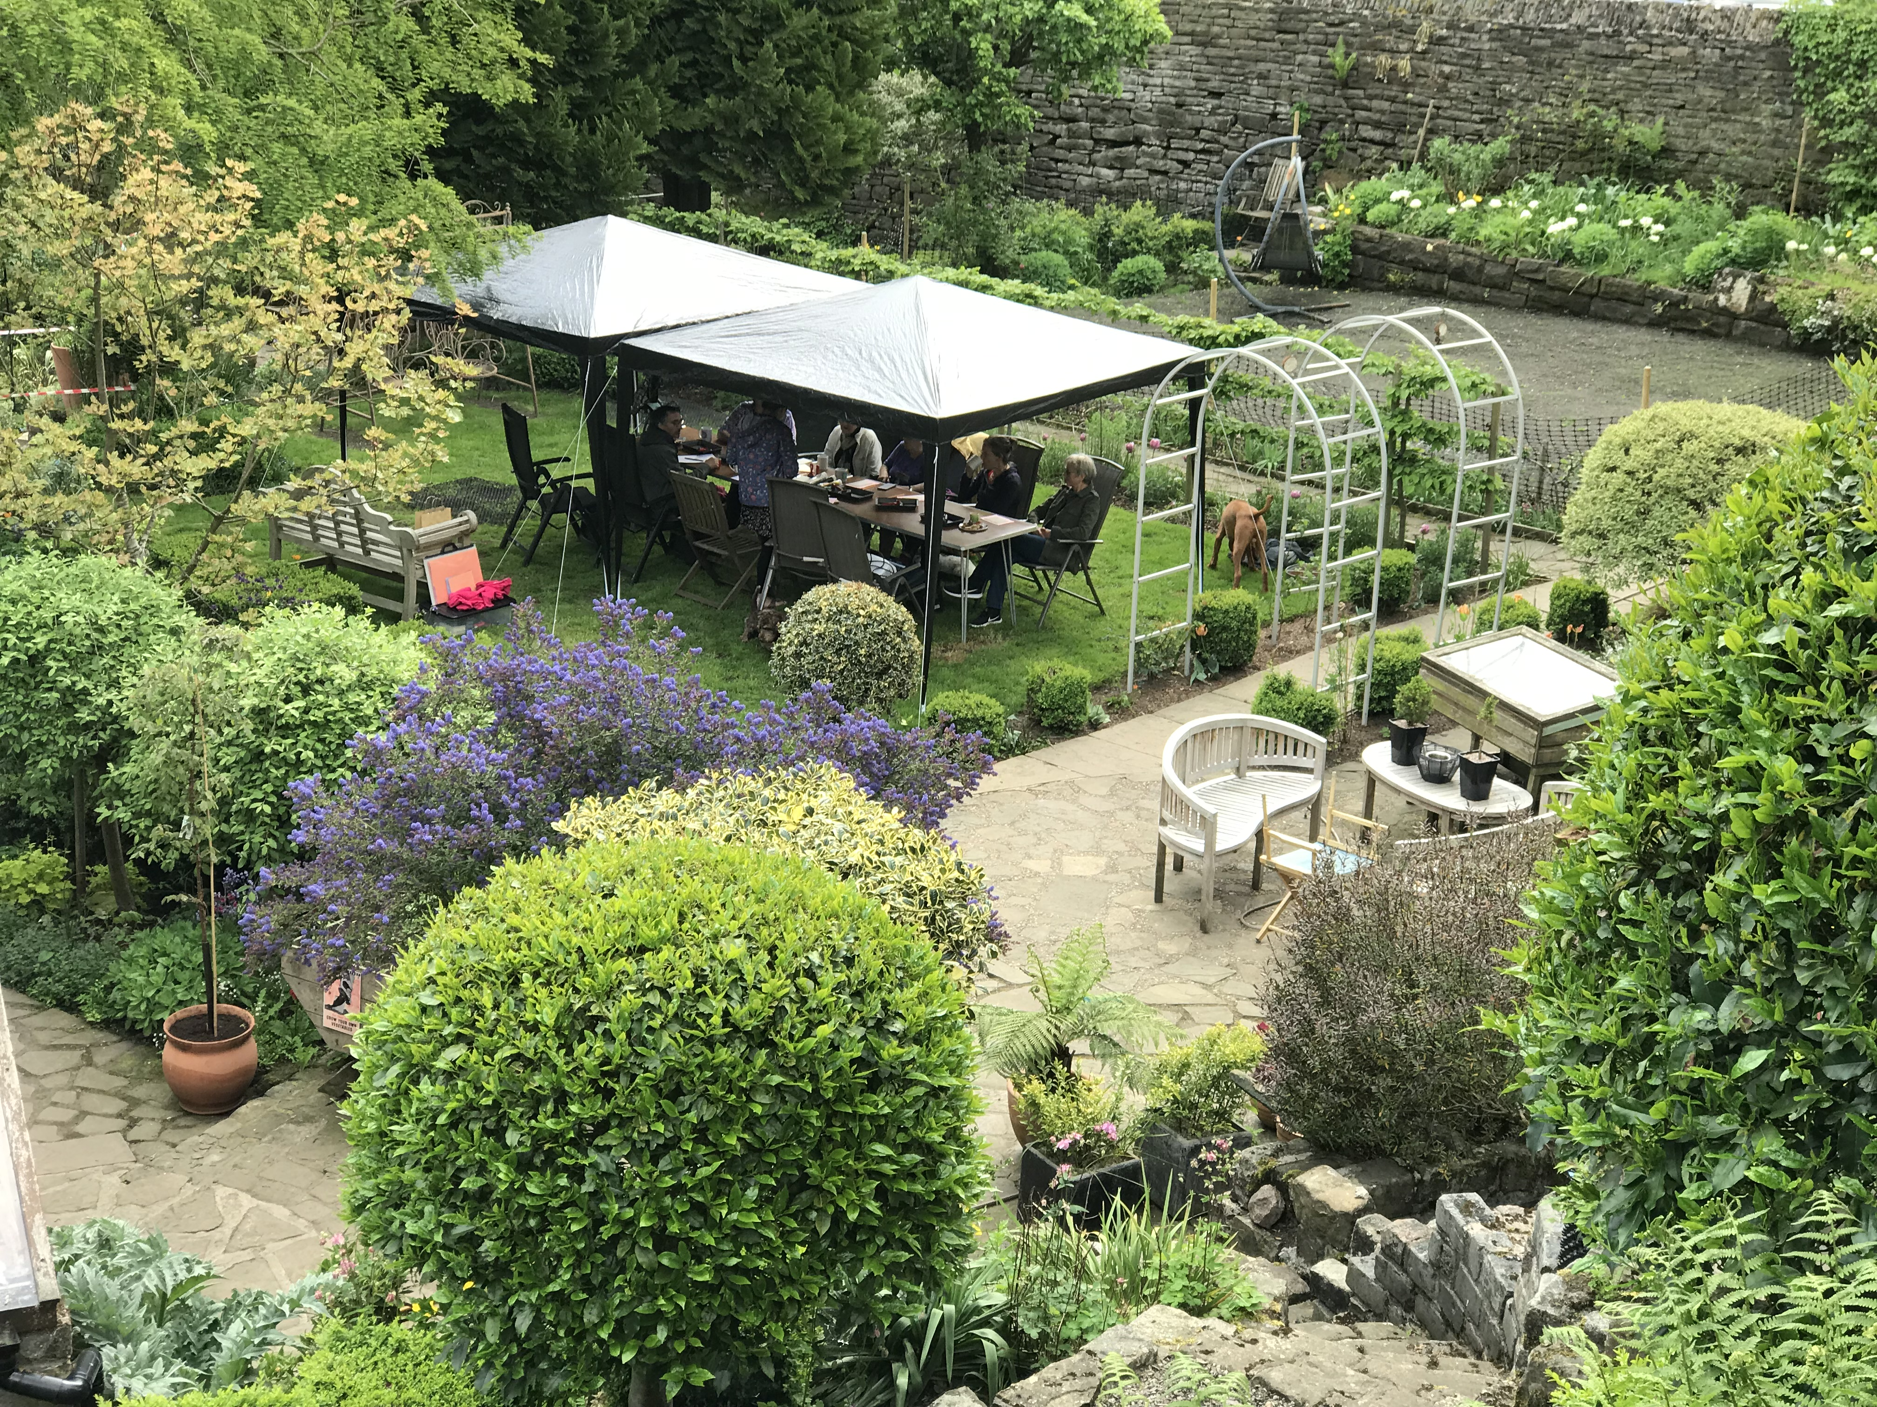
Do you have any other questions about the Mindfulness, Drawing & Writing course? If so we’ll be happy to help. Please contact Helena on: helenad1009@me.com or call 07831 505624.

